2018 Components Catalogue

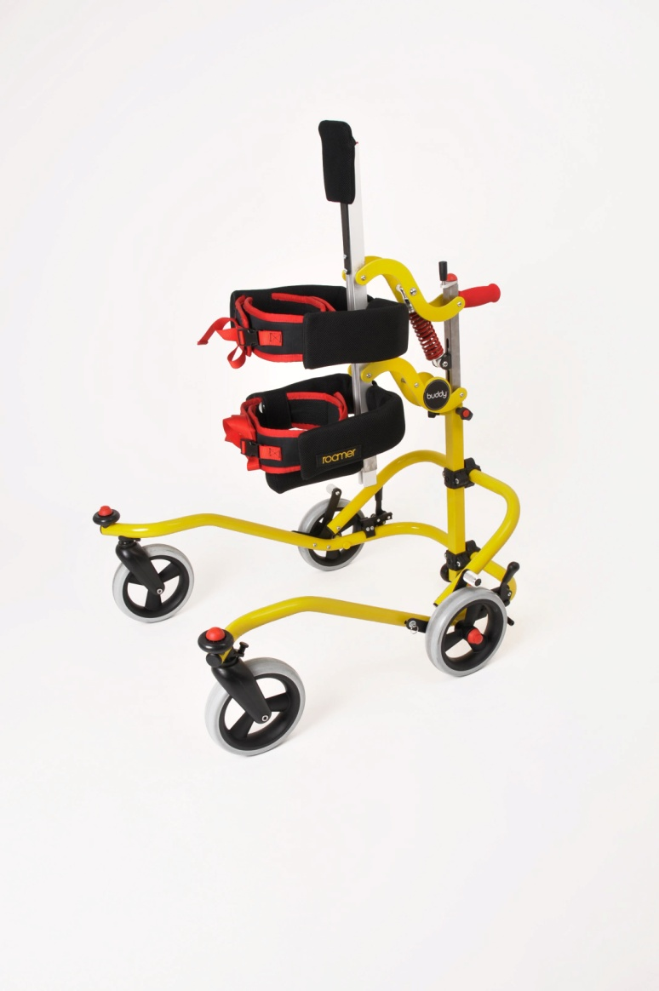

Index
Components / spare parts
Page

Product Overview 3
Base Frame 4
Item 1 – Bumper wheel 5
Item 2 – End Cap 30mm 5
Item 3 – Front Castor 6
Item 4 – Front wheel 6
Item 5 – Rear wheel 7
Item 6 – Parking brake left side with Clamp 7
Item 7 – Parking brake right side with Clamp 8
Item 8 – Anti roll back system right 8
Item 9 – Anti roll back system left 9
Item 10 – Upper & Lower cross clamp 9

Back column 10
Item 11 – Back column assembly 11
Item 12 – Buddy logo domed sticker 11
Item 13 – Rear handle 13
Item 14 – Revolving Handle 13

Front column 12 /14
Item 15 – Set of lateral support Size 1 or 2 15
Item 16 – Set of lateral support Size 3 or 4 15
Item 17 – Headrest 16
Item 18 – Standard K Slot Stone M6 16
Item 19 – Large K Slot Stone M8 17
Item 20 – Lateral clamp Size 2 17
Item 21 – Lateral Clamp Size 3 SA 18
Item 22 - Red extrusion cover cap Standard/Large 18
Item 23 – Central positioning bar Standard /Large 19

Accessories
Central positioning bar complete with abduction pad Size 2/3 20
Shoulder Positioners Complete Set 20
Arm hold Options (Straight) 21
Arm Hold Options (Bumper Bar) 21
Headrest (Large and Special) 22
Ankle Straps 22

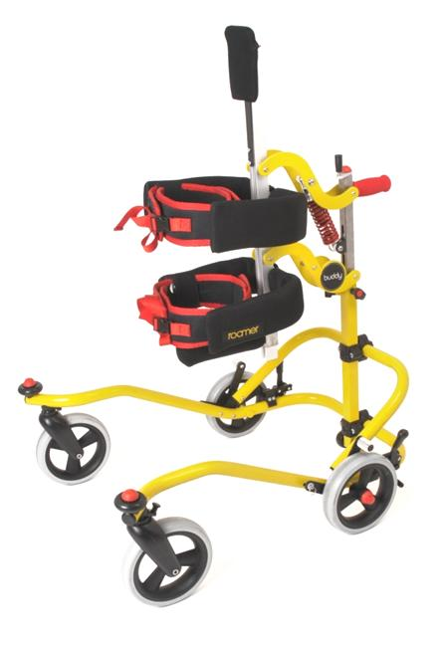

3

2

1

Item No. | Assembly Group | Page No.
1 | Base frame | 4 - 9
2 | Back Column | 10 – 12
3 | Front Column | 13 - 19
Base frame – Available in 2 Sizes 2 or 3.
9
5
7
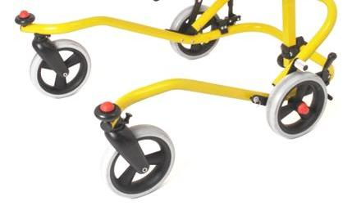
10
8
6
1
2
3
4

Item No. | Product Description | Page
1 | Bumper wheel | 5
2 | Base End Cap 30mm | 5
3 | Front castor | 6
4 | Front wheel | 6
5 | Rear wheel | 7
6 | Parking brake left side with Clamp | 7
7 | Parking brake right side with Clamp | 8
8 | Anti-roll back system left side | 8
9 | Anti-roll back system right side | 9
10 | Upper & Lower cross-clamp | 9

Item No.1

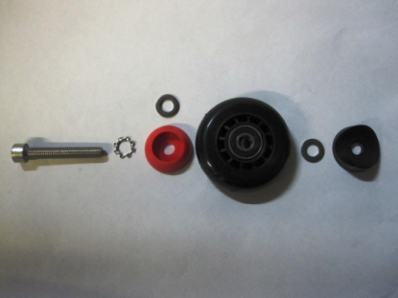
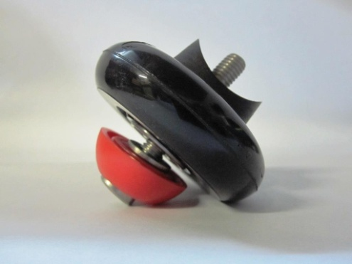

Product Code | Product Description
BRSA-004 | Bumper Wheel Assembly

Check to ensure Items 2-4 do not also need replaced

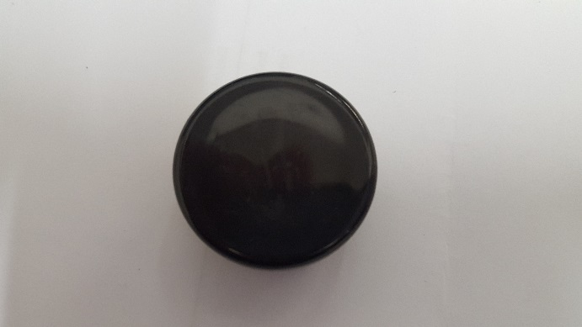
Item No.2

Product Code | Product Description
BUD-0034 | Base End Cap 30mm
Check to ensure Items 1, 3 & 4 do not also need replaced

Item No.3
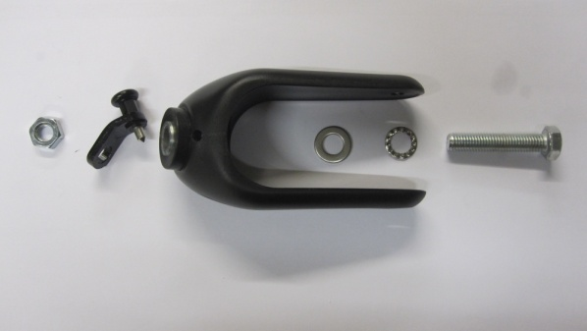
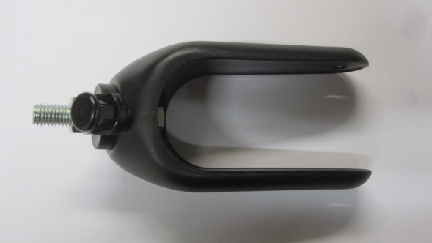

Product Code | Product Description
BUD-R023 | Front Caster Assembly

Check to ensure Items 1, 2 & 4 do not also need replaced

Item No.4
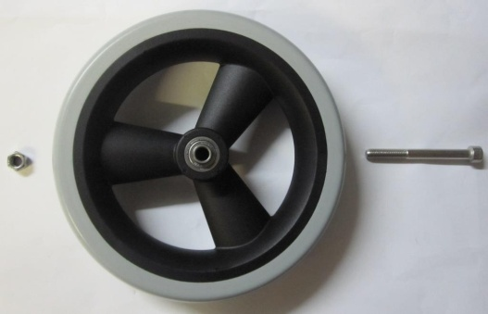
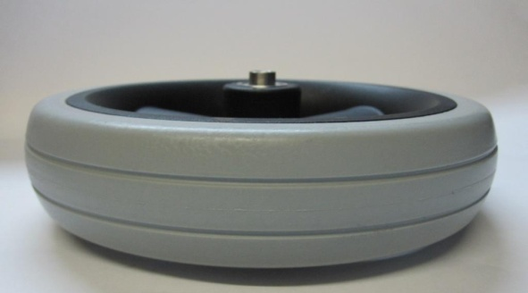

Product Code | Product Description
BUD-R025 | Front Wheel
BUD-0011 | M8x70 Socket Cap Screw
BUD-0014 | M8 Nyloc Nut

Check to ensure Items 1, 2 & 3 do not also need replaced
Item No.5

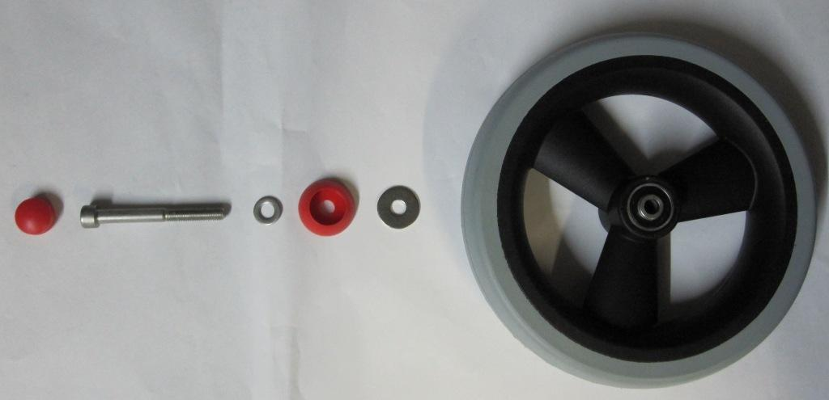
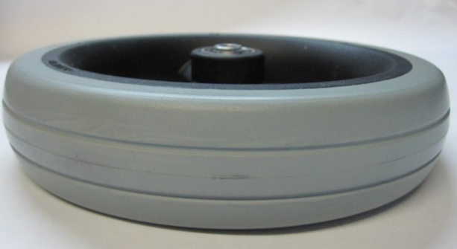

Product Code | Product Description
BUD-RO26 | Rear Wheel
BUD-0002 | Secure Cover Cap Base
BUD-0003 | Secure Cover Cap
BUD-0040 | M8 Washer Large
BUD-0015 | M8 Washer small
BUD-0042 | M8x80 Socket Cap Screw

Item No.6 BUD-R053 Parking Brake and Clamp
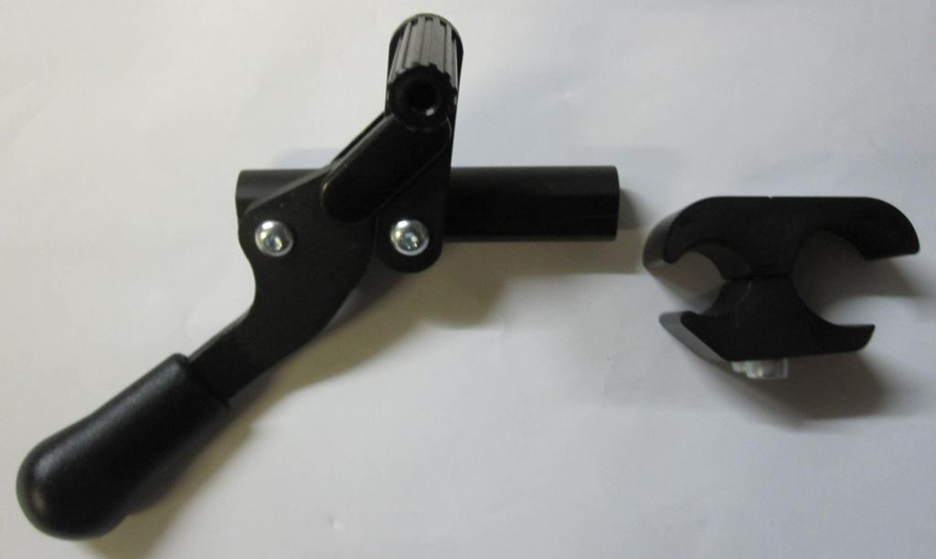
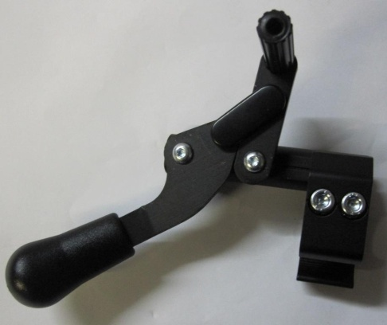

Product Code | Product Description
BUD-RO51 | Parking brake left side assembly

Item No.7 BUD-R053 Parking Brake and Clamp

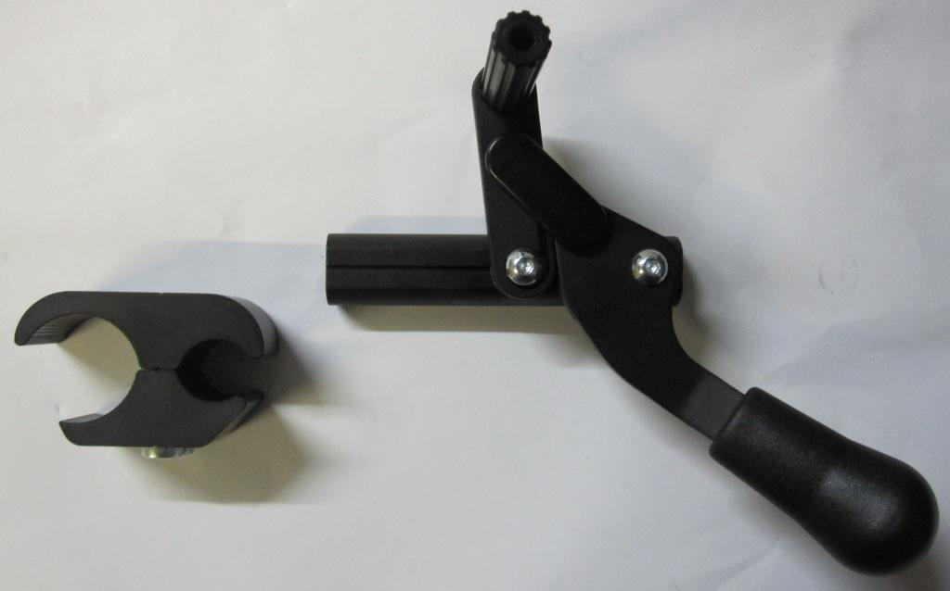
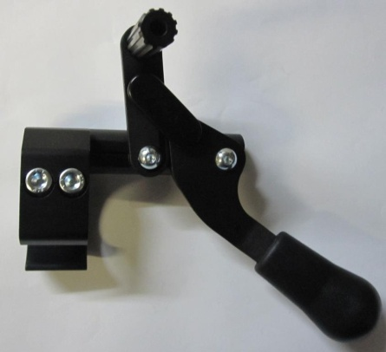

Product Code | Product Description
BUD-RO52 | Parking brake right side assembly

Item No.8

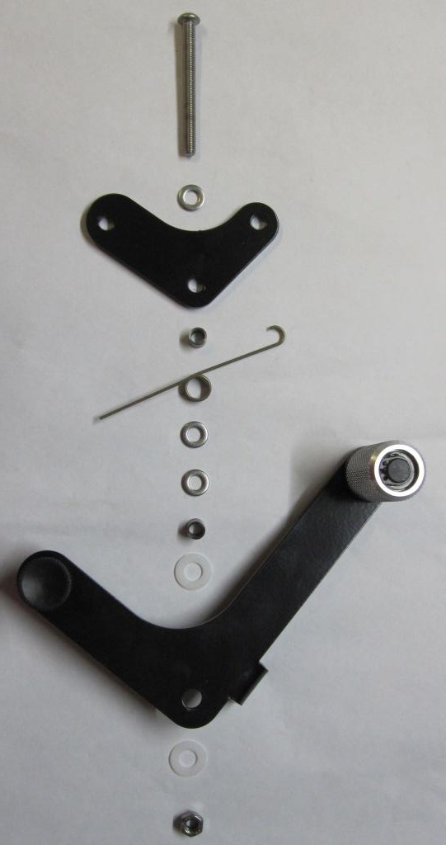
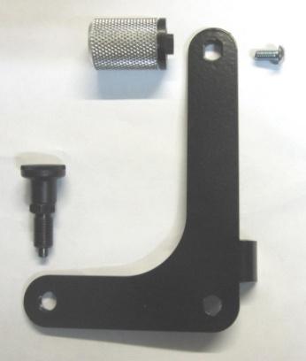

Product Code | Product Description
ROA011-L | Anti roll back system left side assembly

Item No.9

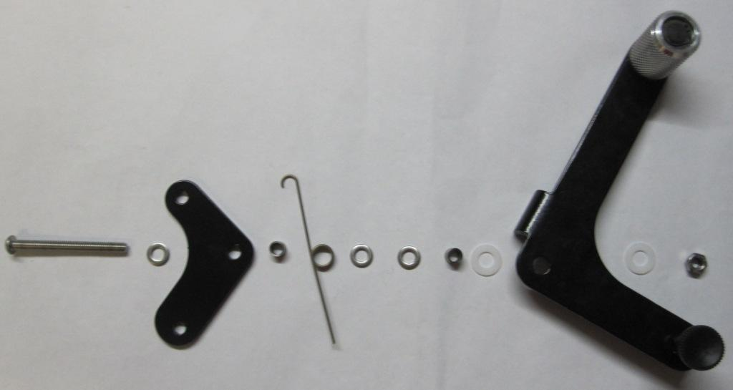
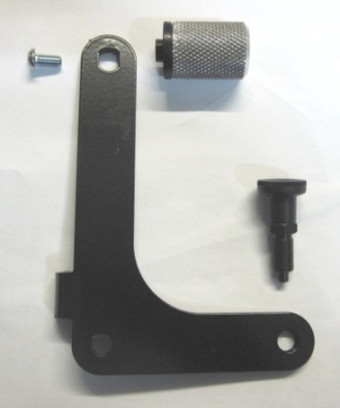

Product Code | Product Description
ROA011-R | Anti roll back system right side assembly

Item No.10 Cross Clamp Available in 3 Sizes
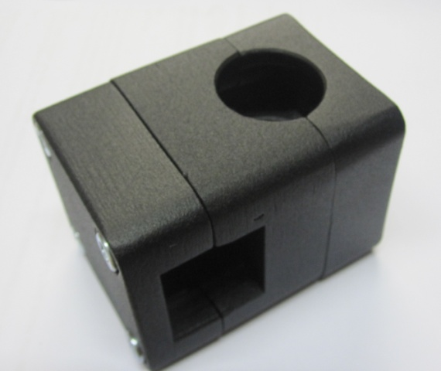

Product Code | Product Description
BUD-R019-1 | Cross clamp assembly Size 1
BUD-R019-2 0r -3 Cross clamp assembly Size 2 or 3

Back Column

141
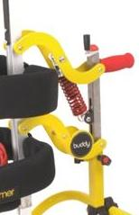
131
12
111

Item No. | Product Description | Page
11 | Back Column Holder | 11
12 | Buddy Logo Domed Sticker | 11
 | Front Column SA | 12
13/14 | Red Foam Grip and Revolving Handle | 13

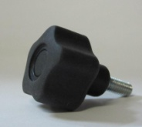
Item No. 11 Back Column Available in 3 Sizes 1 / 2 or 3
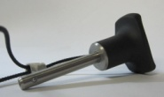
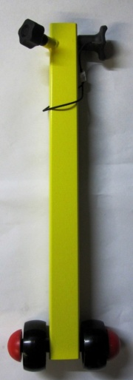
Item B
Item A
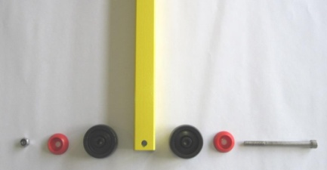

Item C

Item | Product Code | Product Description
11 | R0A003/1 2 or 3 | Back Column Holder assembly
 | BUD-R020/1 | Telescope Base (Size 1)
 | BUD-R020/2 | Telescope Base (Size 2)
 | BUD-R020/3 | Telescope Base (Size 3)
A | BUD-0020 | Soft Touch Knob
B | BUD-R056 | Ball lock pin / 2 Sizes 2 or 3
C | BUD-0014 | M8 Nyloc Nut
C | BUD-0002 | Secure Cover Cap Top
C | BUD-0003 | Secure Cover Cap Base
C | BUD-R028 | Anti-Tip Wheel
C | BUD-R028 | Anti-Tip Wheel
C | BUD-0003 | Secure Cover Cap Base
C | BUD-0012 | M8 X 100 Socket Cap Screw
C | BUD-0002 | Secure Cover Cap Top

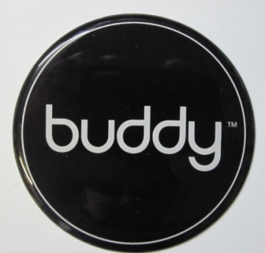
Item No. 12

BUD-0035 Buddy Sticker
Product Code | Product Description
Product Code | Product Description

BRSA-003-2 (Size 2) Front Column Sub Assembly
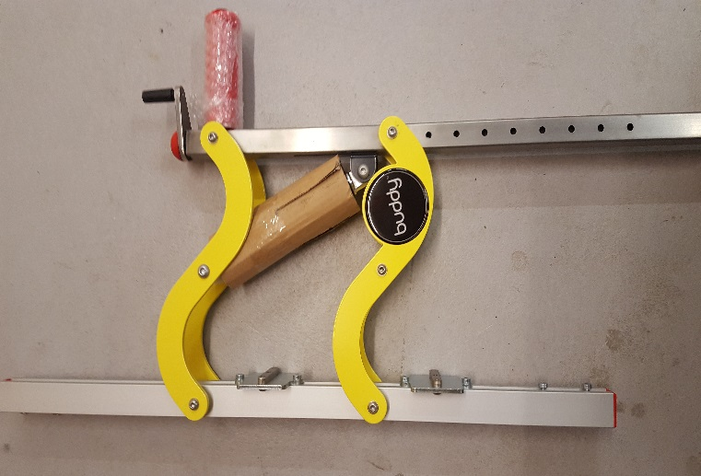
BRSA-003-3 (Size 3) Front Column Sub Assembly

Item No. 13

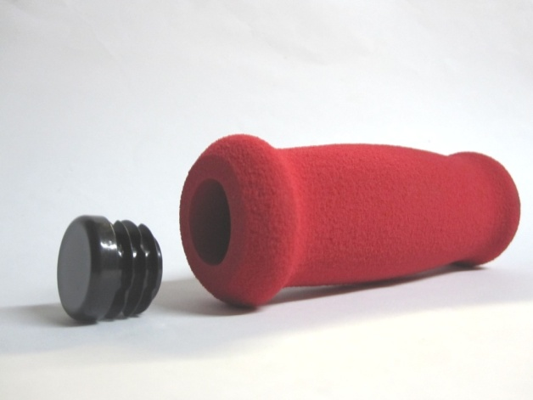

Product Code | Product Description
BUD-0001 | Foam grip - red
BUD-0004 | Dia. 20mm End Cap

Item No. 14

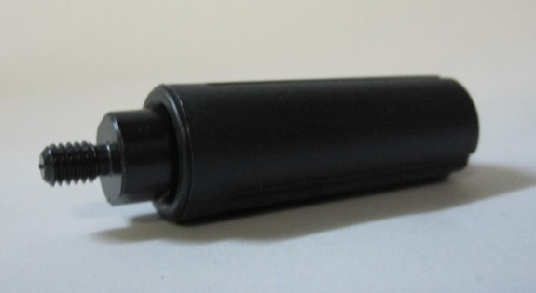

Product Code | Product Description
BUD-R011 | Revolving Grip

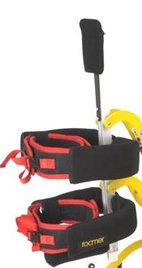
Front Column – Sub Assembly as below. Available in 2 Sizes – 2 or 3

22
18
15
16
17

19
20
21
19
20

22
23

Item No. | Product Description | Page
15 | Set of lateral supports Size 1 or 2 | 15
16 | Set of lateral supports Size 3 or 4 | 15
17 | Headrest | 16
18 | Standard K M6 slot stone | 16
19 | Large K M8 slot stone | 17
20 | Lateral clamp Size 2 | 17
21 | Lateral clamp Size 3 Sub Assembly | 18
22 | Red extrusion cover cap | 18
23 | Central Positioning bar | 19

Item No. 15 - Available in 4 Sizes

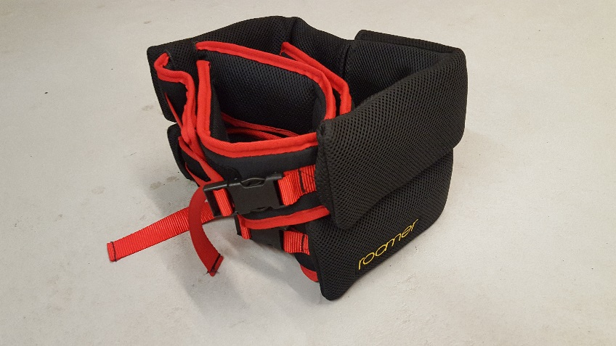

Item | Product Code | Product Description
15.1 | ROA205-1 | Lateral Pair Size 1
15.2 | ROA205-2 | Lateral Pair Size 2

Item No. 16
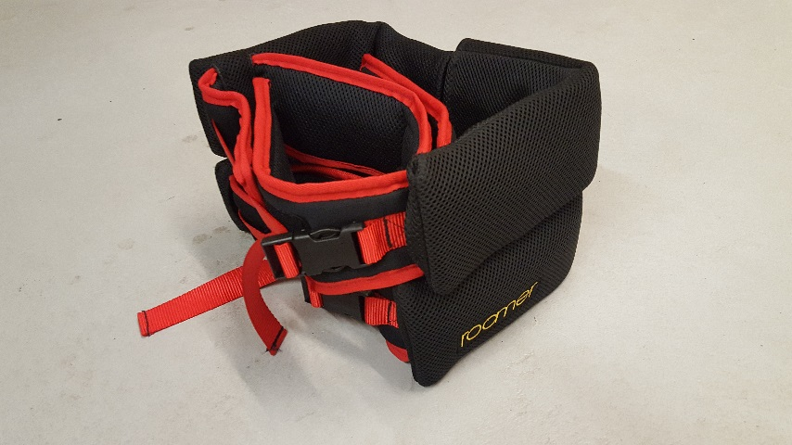

Item | Product Code | Product Description
16.1 | ROA205-3 | Lateral Pair Size 3
16.2 | ROA205-4 | Lateral Pair Size 4

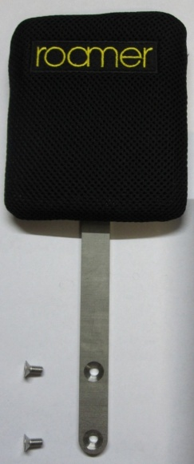
Item No. 17

Product Code | Product Description
ROA007 | Headrest assembly
BUD-R043 | Headrest Bar
BUD-0031 | M6x12 Countersunk Socket cap screw

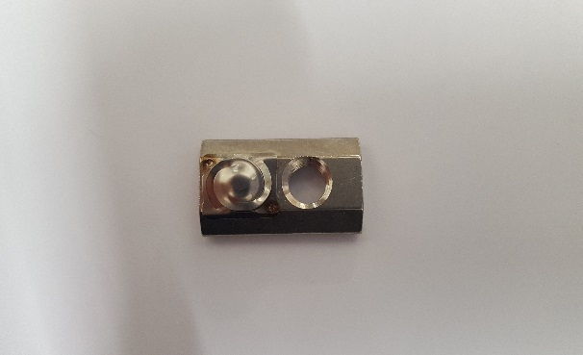
Item No. 18

Product Code | Product Description
BUD-0052 | Standard K slot stone/ M6 with spring

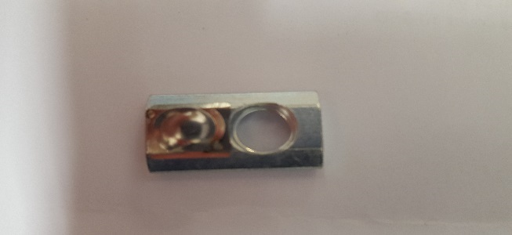
Item No. 19

Product Code | Product Description
BUD-0052-L | Large K slot stone / M8 with spring

Item No. 20
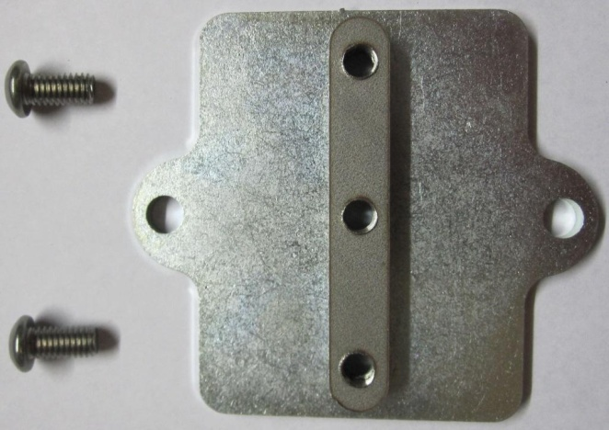
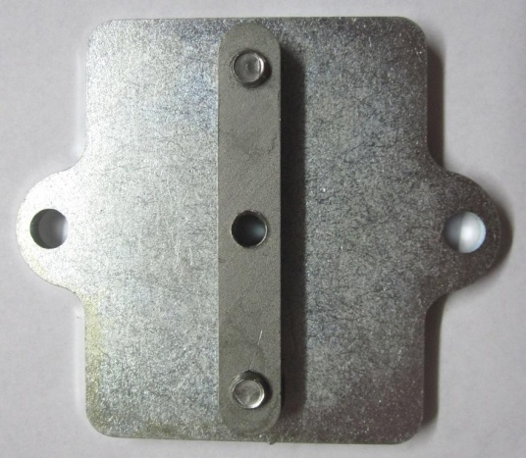

Product Code | Product Description
BRSA-002 | Lateral Clamp Size 2
BUD-0030 | M6x12 Socket Cap screw

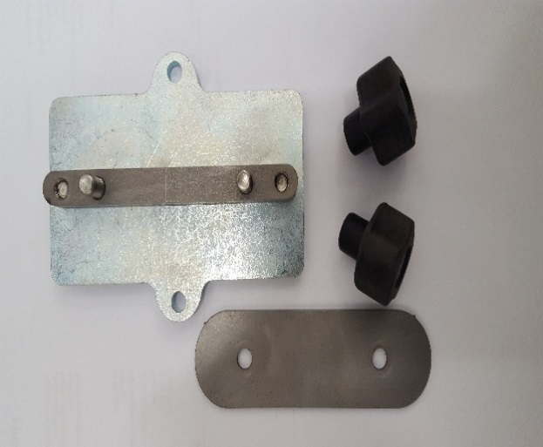
Item No. 21

Product Code | Product Description
BRSA -002-3 | Lateral Clamp Size 3 Sub Assembly

BUD-0029-3 Long Washer and BUD-0051 – Female soft touch Knob

Item No. 22 Available in 2 Sizes

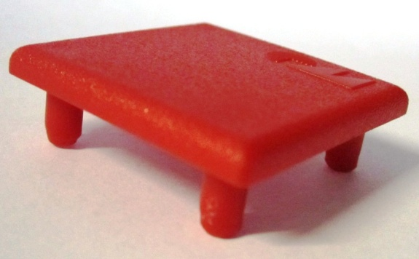

Product Code | Product Description
BUD-R034 | Red Extrusion Cover Cap

BUD-R034-L Large Extrusion Cover Cap

Item No. 23 Available in 2 Sizes / 2 or 3
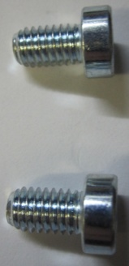
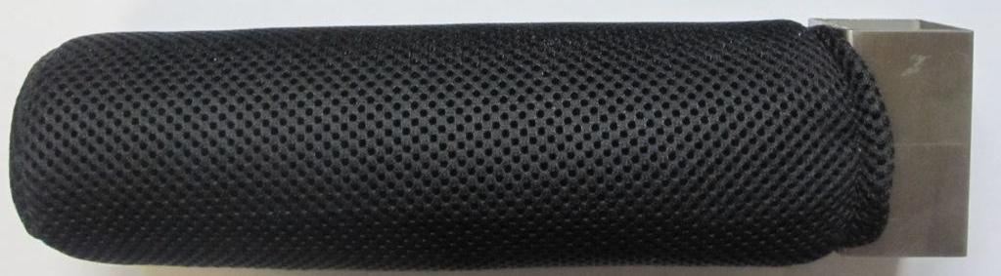

Product Code | Product Description
ROA006-2 or -3 | Standard/Large Central positioning bar
BUD-0032/0030 | M6x10/x12 Socket Cap screw

Accessories

Central positioning bar complete with abduction pad – Available in 2 Sizes/ 2 or 3

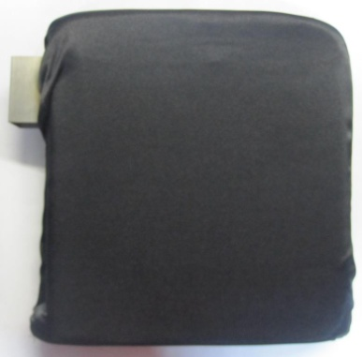

Product code | Product Description
ROA012 | Central positioning bar complete with abduction pad
ROA312 Size 3 Central Positioning Bar with Abduction Pad.
Product Code | Product Description
ROA-008 | Complete set of Shoulder Positioners
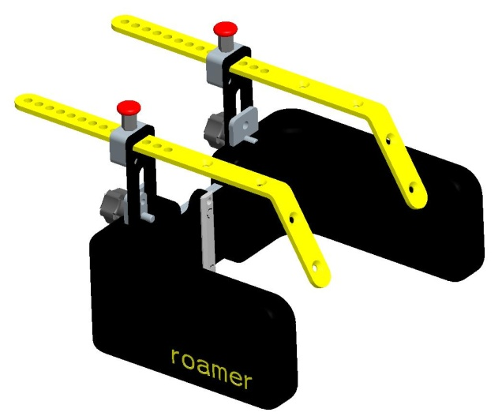
Shoulder Positioners Complete Set
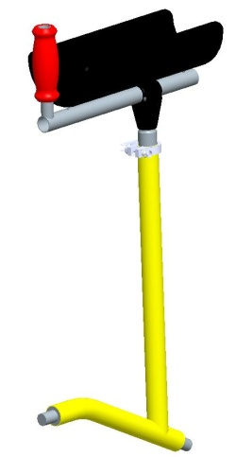
Arm hold left and Right – Available in 2 Sizes / Check Base frame size. Photo below is Set of Straight arm holds

Product Code | Product Description
ROA-009L / R | Arm hold left and Right

Arm holds are available in Straight or Bumper Bar style. Codes ROA-009 for Set of Straight or ROA009B for set of Bumper Bar style. Photo below is Bumper Bar style.
Product Code | Product Description
ROA-009B | Bumper Bar Style Arm hold (Complete Set)

Headrests - Available in Large or Special.
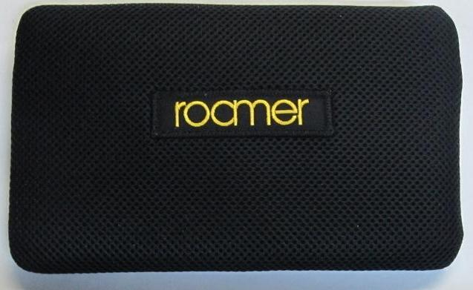

Product Code | Product Description
ROA007L | Large headrest
ROA007S | Special headrest

Ankle Straps also available
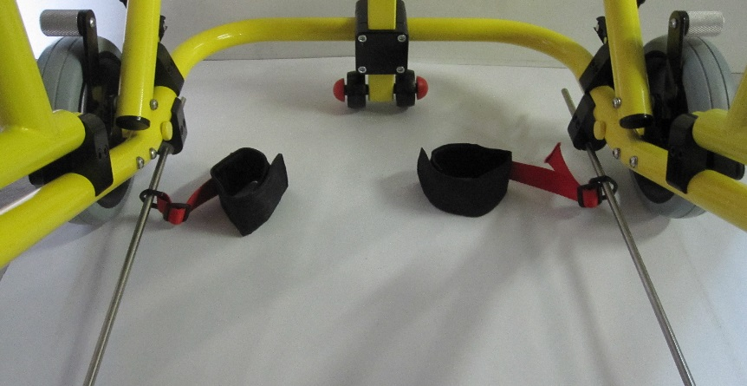
ROA010 – Abduction Ankle Straps.

For further information, downloads, inspirational stories, videos, features and much more visit:
www.mooringsmediquip.com

TEL: +44(0) 28 25632777 or Fax: +44(0) 28 25632777
Moorings Mediquip
51 Slaght Road
Ballymena
BT42 2JH
Co.Antrim

Version 2.0
Moorings
United King
BT42 2JH

Tel: +44(0) 28 2563 2777
Fax: +44(0) 28 2563 2272
www.mooringsmediquip.com

